Year 11 Semester Two Examination, 2016

MARKING KEY

CHEMISTRY

- Which of the following atoms will have the smallest atomic radius?

  - F
  - Cℓ
  - S
  - O

- Which of the following pairs of elements will have the largest difference in electronegativities?

  - boron and bromine
  - chlorine and carbon
  - rubidium and radium
  - sodium and sulfur

- In an atomic absorption spectroscopy (AAS) the wavelength of light absorbed is related to the

  - number of electrons in the atom.
  - differences between the energy levels for electrons in the atom.
  - energy of the outer (valence) shell of electrons.
  - mass of the ion formed when the atom is ionised.

- Which one of the following was the major conclusion from Rutherford’s gold foil experiment?

  - Elements contain one type of atom.
  - Most of the mass of the atom was contained in a relatively small nucleus.
  - Electrons existed in shells with different energy levels.
  - Metallic bonding in gold made the metal malleable.

- Which one of the following isotopes will have a different number of neutrons from the other three?

  - carbon-14
  - nitrogen-15
  - oxygen-15
  - fluorine-17Which one of the following statements about a mass spectrometer is false?

- Which one of the following statements about a mass spectrometer is false?
  - Ionisation in a mass spectrometer always produces positive ions.
  - The heavier particles will be deflected more in the magnetic field than the lighter particles.
  - The charged ions are accelerated towards the magnetic field using an electric field.
  - A mass spectrometer can provide information about relative amount of the isotopes in a sample.

- In a gas chromatograph

  - the retardation factor indicates the identity of the substance.
  - smaller particles have a longer retention time than larger particles.
  - the retention time indicates the amount of the substance and the peak height indicates the identity of the substance present.
  - The retention time indicates the identity of the substance and the area under the peak indicates the amount of the substance present.

- Which one of the following ionic formulae is correct?

  - Aℓ(PO₄)₃
  - Na₂HCO₃
  - Mg(NO₃)₃
  - CaS

- Which one of the following molecules is a polar molecule?

  - CO₂
  - O₂
  - NH₃
  - CH₄

- In which of the following pairs of molecules would dispersion forces be the most significant intermolecular force?

  - CO₂ and CO₂
  - H₂O and H₂O
  - NH₃ and H₂O
  - SO₂ and SO₂

- Which one of the following is the IUPAC name for the molecule shown below?

CH₃CH₂CH₂CH(CH₃)CH(CH₃)CH₃

  - 3,5-methylhexane
  - 2,3-dimethylhexane
  - 2,3-dimethyloctane
  - 3,5-dimethylhexane

- Which of the following would have a high melting point?

- magnesium chloride
- magnesium
- chlorine
- graphite
- carbon tetrachloride

  - iv and v only
  - iii, iv and v only
  - ii and iv only
  - i, ii and iv only

- Which one of the following is not a process used to treat water from ground water or seawater before it is supplied to houses as drinking water?

  - crystallisation
  - desalination
  - fluoridation
  - chlorination

- Incomplete combustion of hydrocarbons

  - occurs when not all the hydrocarbon is combusted, leaving some of the hydrocarbon left over.
  - occurs when unsaturated hydrocarbons burn in oxygen.
  - may result in the production of carbon monoxide.
  - occurs when the heat supplied is not enough to overcome the activation energy for the reaction.

- Read the following explanation:

“The rate of a chemical reaction is determined by the number of successful collisions. If more particles make up a solid are exposed, there will be a greater total number of collisions. Therefore, the number of successful collisions will increase and the reaction will proceed faster”

Which one of the following factors is this statement referring to?

  - using a catalyst
  - temperature
  - concentration
  - surface area

- An enthalpy diagram for a chemical reaction is shown below.
Reactants
Products
Reaction Progress
Enthalpy
(kJ mol⁻¹)
400

300

200

100

Estimate the enthalpy change for the forward reaction.

  - + 300 kJ mol⁻¹
  - – 100 kJ mol⁻¹
  - – 300 kJ mol⁻¹
  - + 100 kJ mol⁻¹

- The human stomach contains gastric juice, which contains approximately 1% (by
mass) of hydrochloric acid. Which one of the following would most likely be the pH inside our stomachs?

  - 1
  - 6
  - 7
  - 9

- Which one of the following equations represents a substitution reaction?

  - C₃H₆ + Br₂ → C₃H₆Br₂
  - 2 C₄H₁₀ + 13 O₂ → 8 CO₂ + 10 H₂O
  - C₂H₆ → C₂H₄ + H₂
  - C₆H₆ + Cℓ₂ → C₆H₅Cℓ + HCℓ

- A student had two colourless solutions to identify. She knew that one was sodium carbonate and one was potassium chloride. Which of the following tests could be used to distinguish between the two solutions?

- adding dilute hydrochloric acid to both solutions
- adding calcium nitrate solution to both solutions
- adding universal indicator to both solutions
- adding silver nitrate solution to both solutions

  - ii, iii and iv only
  - i and iii only
  - ii and iii only
  - i, ii, iii and iv

- The equation for the combustion of methane is shown below:

CH₄(g) + 2 O₂(g) → CO₂(g) + 2 H₂O(ℓ) ΔH = - 891 kJ mol⁻¹

Which one of the following can be deduced from this equation?

  - it is an exothermic reaction
  - 2 moles of oxygen gas are required for the complete combustion of 1 mole of methane
  - it is a fast chemical reaction
  - at STP, 1.00 L of carbon dioxide is produced for each mole of methane combusted
  - 891 kJ of energy is released when 16.04 g of methane is combusted

  - i, ii and iii only
  - i, ii, iii and v only
  - i and ii only
  - i, ii and v only

End of Section One

Section One: Multiple-choice SOLUTIONS

Question | Correct response
1 | A
2 | D
3 | B
4 | B
5 | C
6 | B
7 | D
8 | D
9 | C
10 | A
11 | B
12 | D
13 | A
14 | C
15 | D
16 | D
17 | A
18 | D
19 | D
20 | D

Section Two: Short answer 35% (56 Marks)

Question 21 (5 marks)

Write ionic equations, including state symbols, for any reactions that occur in the following situations.

(a) Dilute nitric acid solution is added to solid copper(II) carbonate. (3 marks)

2 H⁺(aq) + CuCO₃(s) → Cu²⁺(aq) + CO₂(g) + H₂O(ℓ)

Description | Marks
correct species | 1
balanced equation | 1
correct state symbols | 1
Total | 3

(b) Solid sodium hydroxide pellets are added to distilled water. (2 marks)
H₂O
NaOH(s) → Na⁺(aq) + OH⁻(aq)

Description | Marks
correct species | 1
correct state symbols | 1
Total | 2

Question 22 (6 marks)

(a) For each of the following reactions, describe expected observations, including any

(i) Dilute sulfuric acid is added to zinc metal (2 marks)

Description | Marks
any two from:  - (silver grey) solid dissolves in clear solution  - colourless, odourless gas produced and colourless solution produced | 1 each
Total | 2

(ii) 2 HCℓ(aq) + Ag₂O(s) → 2 AgCℓ(s) + H₂O(ℓ) (2 marks)

Description | Marks
brown solid dissolves in colourless solution | 1
colourless solution produced and white solid | 1
Total | 2

(b) A student noted the following observations in his notebook.

“A colourless solution and a pale pink solution were added together and a pale pink precipitate was formed. No gas was produced.”

Write an ionic equation (including state symbols) for a reaction that would produce these observations. (2 marks)

CO₃²⁻(aq) + Mn²⁺(aq) → MnCO₃(s)

Description | Marks
correct species (could also be hydroxide/phosphate/sulfide) | 1
correct state symbols and balanced | 1
Total | 2

Question 23 (6 marks)

Examine the displayed structure of cis 5,5-dimethylhex-2-ene below.

(a) Draw the displayed structure of a structural isomer of this compound and name the isomer that you have drawn.

Description | Marks
correct structural formula (must be structural isomer) C₈H₁₆ | 1
correct name for given molecule | 1
Total | 2

(b) Draw the displayed structure and name the product of the reaction of this molecule with bromine. (2 marks)

Description | Marks
correct structural formula  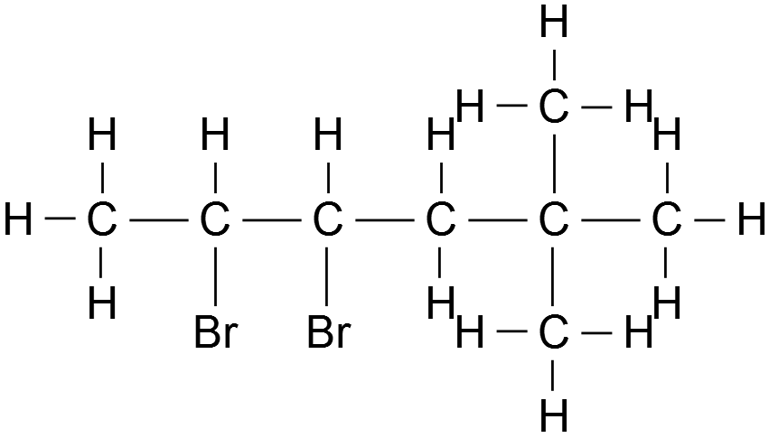 or 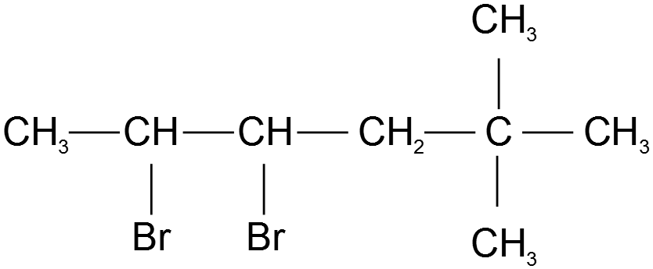 | 1
2,3-dibromo-5,5-dimethylhexane | 1
Total | 2

(c) Explain why 5,5-dimethylhex-2-ene exhibits geometric (cis/trans) isomerism but the molecule that is your answer to part (b) does not. (2 marks)

Description | Marks
Product contains single bonds which can rotate | 1
5,5-dimethylhex-2-ene contains a double bond that cannot rotate | 1
Total | 2

Question 24 (7 marks)

The following answers were seen on a Year 11 student’s chemistry test. Unfortunately, they are all incorrect. For each one, rewrite the statement making it correct.

(a) ‘Dispersion forces only occur between non-polar molecules.’ (2 marks)

Correct statement:

Description | Marks
Dispersion forces occur between all particles | 1
In non-polar molecules they are the most significant as they are the only intermolecular forces / secondary bonds occurring | 1
Total | 2

(b) ‘Chlorine has a larger atomic radius than phosphorus because chlorine atoms contain more electrons than phosphorus atoms.’ (2 marks)

Correct statement:

Description | Marks
Chlorine has a smaller atomic radius than phosphorus | 1
because it has a higher nuclear charge | 1
Total | 2

(c) ‘Sodium chloride is soluble because the bonds between the sodium ions and the chloride ions are weak.’ (3 marks)

Correct statement:

Description | Marks
Sodium chloride is soluble because the bonds formed between sodium ions and chloride ions and water | 1
are strong enough to overcome | 1
the existing bonds within the (ionic) lattice/network/crystal | 1
Total | 3

Question 25 (13 marks)

(a) For each molecule listed in the table below draw the structural formula, representing all valence shell electron pairs as : or as — , indicate the shape of the species by a sketch or a name and state the polarity of the molecule. (9 marks)

Species | Electron Dot Diagram  (Lewis diagram) | Shape  (sketch or name) | Polarity  (polar or  non-polar
trichloromethane  (chloroform)  CHCℓ₃ | 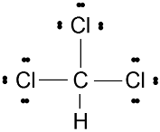  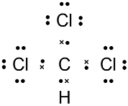  or | tetrahedral | polar
methanal  (formaldehyde),  CH₂O | 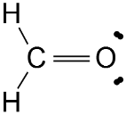  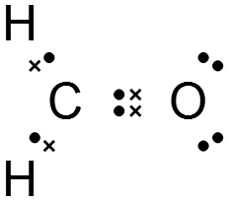  or | trigonal planar | polar
Ammonia,  NH₃ |   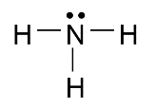  or | trigonal pyramidal | polar

Description | Marks
1 mark for each correct answer | 0 - 9
Total | 9

(b) (i) Which substance above would display hydrogen bonding between
(1 mark)

Description | Marks
ammonia | 1
Total | 1

(ii) Draw a diagram showing how this hydrogen bonding is formed. (3 marks)


δ –
δ+
Hydrogen bonding

Description | Marks
diagram shows dipole moments correctly labelled on each molecule | 1
hydrogen bonding shown between the hydrogen on the ammonia and the nitrogen on the other ammonia | 1
bonding clearly shown between the hydrogen and one of the lone pars on the nitrogen atom | 1
Total | 3

Question 26 (10 marks)

The ‘pop test’ is used to test for the presence of hydrogen gas. The test normally involves an up-side down test tube being filled with hydrogen and a flame is brought close to the open end of the test tube. Hydrogen gas undergoes an exothermic reaction with oxygen gas in the air to produce water vapour. The ‘pop’ is made by the air in the test tube expanding out of the end of the test tube.

(a) Draw a fully labelled enthalpy diagram for this reaction, including activation energy. (5 marks)

H₂ + O₂
Reaction Progress
Enthalpy

H₂O
Activation energy / E_{A}
ΔH

Description | Marks
reactants and products labelled | 1
products lower than reactants | 1
ΔH labelled | 1
activation energy correctly shown and labelled | 1
y axis labelled Enthalpy (accept H) and x axis Reaction Progress | 1
Total | 5

(b) Explain why a flame is used to start the reaction. (2 marks)

Description | Marks
energy from flame | 1
required to overcome the activation energy / break bonds | 1
Total | 2

(c) Explain why the air in the test tube expands out of the end of the test tube.
(3 marks)

Description | Marks
heat is released from the (exothermic) reaction | 1
air in the test tube warms up / average kinetic energy of particles increases | 1
air (gas) expands when it is heated | 1
Total | 3

Question 27 (9 marks)

Relative mass of N⁺ ion | Relative intensity
14.0 | 34.0
15.0 | 0.370
A sample of nitrogen was analysed in a mass spectrometer and the following results were obtained:

(a) Calculate the relative atomic mass of this sample of nitrogen. (2 marks)

Description | Marks
M(N) = ((14.0 × 34.0) + (15.0 × 0.370) / 34.370 | 1
= 14.01 | 1
Total | 2

(b) Comment on whether you think this is would be a naturally occurring sample of
nitrogen. (2 marks)
Description | Marks
Yes | 1
Because the calculated relative mass is the same as the given value (on the data sheet) | 1
Total | 2

(c) The mass spectrum for this sample also contained peaks at relative masses of 28, 29, and 30.

(i) Account for the appearance of the peak seen at a relative mass of 29.
(2 marks)

Description | Marks
an N₂⁺ ion | 1
containing one atom of N-14 and one atom of N-15 | 1
Total | 2

(ii) Which one of these three peaks would have the lowest relative intensity?
(1 mark)

Description | Marks
30 | 1
Total | 1

(iii) Which one of species causing these three peaks (28, 29, and 30) would have been deflected most by the magnetic field? Briefly explain your answer.
(2 marks)

Description | Marks
28 | 1
it has the lowest mass | 1
Total | 2

End of Section Two

Section Three: Extended answer 40% (64 Marks)

Question 28 (17 marks)

Sulfuric acid is used at the electrolyte in car batteries.

(a) Using the example of sulfuric acid explain what is meant by a strong acid. Use an equation in your answer. (3 marks)

Description | Marks
a strong acid totally ionises (accept dissociates) in solution / produce a high concentration of hydrogen ions when dissolved in solution | 1
sulfuric acid molecules ionise in solution | 1
Shown by equation:  either: H₂SO₄(aq) → 2 H⁺(aq) + SO₄^{2–}(aq)  or: H₂SO₄(aq) → H⁺(aq) + HSO₄–(aq)  H₂SO₄(aq) + H₂O(ℓ) → H₃O⁺(aq) + HSO₄–(aq) | 1
Total | 3

(b) The concentration of sulfuric acid in a car battery is found to be 2.15 mol L⁻¹. A car battery contains 0.650 L of sulfuric acid.

(i) Calculate the mass of sulfuric acid in the car battery. (3 marks)

Description | Marks
n(H₂SO₄) = c × V = 2.15 × 0.650 = 1.3975 | 1
m(H₂SO₄) = n × M = 1.3975 × 98.086 | 1
= 137 g (correct sig figs and unit) | 1
Total | 3

(ii) Assuming the density of the acid in the battery is 1.07 g mL⁻¹ calculate the concentration of the sulfuric acid as a percentage by mass. (2 marks)

Description | Marks
m(H₂SO₄)_{solution} = 650 × 1.07 = 695.5 g | 1
%(H₂SO₄) = (137/695.5) × 100 = 19.7% | 1
Total | 2

(c) The car battery was damaged and 0.300 L of the acid leaked onto the floor of the garage. 475 mL of a solution of 2.75 mol L⁻¹ sodium hydroxide was used to neutralise the acid. Show by calculation that this was just enough to neutralise all the spilt acid. (4 marks)

Description | Marks
n(H₂SO₄)_{spilled} = c x V = 2.15 × 0.300 = 0.645 mol | 1
n(NaOH)_{used} = c x V = 2.75 × 0.475 = 1.31 mol | 1
1 mole of H₂SO₄ requires 2 moles of NaOH for neutralisation  or show by equation:  H₂SO₄ + 2 NaOH → + Na₂SO₄ + 2 H₂O | 1
therefore, n(NaOH)_{required} = 0.645 × 2 = 1.29 mol | 1
Total | 4

(d) Powdered aluminium oxide was then sprinkled over the area of the spillage to remove any excess chemicals. Aluminium oxide is an amphoteric substance, which means it can act as an acid or a base.

(i) Explain why aluminium oxide is the substance chosen to complete the clean-up process (2 marks)

Description | Marks
aluminium oxide will neutralise any excess acid (H₂SO₄) | 1
and/or any excess base (NaOH) | 1
Total | 2

(ii) Use your knowledge of reaction rates to explain why the aluminium oxide was used in a powdered form. (3 marks)

Description | Marks
powdered aluminium will have a large surface area | 1
this will increase the number of (successful) collisions | 1
between the particles in the acid/base / H⁺/OH– ions and the aluminium oxide | 1
therefore the reaction rate will increase | 1
Total | 4

Question 29 (12 marks)

In 2006 there was a serious pollution incident in the town of Esperance, caused by the escape of lead carbonate powder from a storage facility at the town’s port.

A team of environmental scientists were asked to analyse a sample of drinking water for lead content. They added excess sodium iodide solution to 100 litres of the drinking water to form a precipitate of lead(II) iodide.

After filtering and drying, the mass of the residue was found to be 0.236 g.

(a) Explain, in with reference to experimental error, why the residue had to be dried before weighing. (2 marks)
(2 marks)

Description | Marks
without drying, the mass of the residue will always be greater than it should be due to the presence of water | 1
this is an example of systematic error | 1
Total | 2

(b) Calculate the concentration of lead(II) ions (Pb²⁺) in the sample of water in

(i) moles per litre. (3 marks)

Description | Marks
n(PbI₂) = m / M = 0.236 / 461.0 = 5.119 × 10⁻⁴ mol | 1
n(Pb²⁺) = 5.119 × 10⁻⁴ mol | 1
c(Pb²⁺) = 5.119 × 10⁻⁴ / 100 = 5.12 × 10⁻⁶ mol L⁻¹ | 1
Total | 3

(ii) grams per litre. (2 marks)

Description | Marks
m(Pb²⁺)_{in 1.00 Litre} = n × M = 5.119 × 10⁻⁶ × 207.2 | 1
c(Pb²⁺) = 1.06 x 10⁻³ g L⁻¹ (correct sig figs and unit) | 1
Total | 2

(c) Suggest one reason why using Atomic Absorption Spectroscopy (AAS) would be

(i) a more economic method for working out the concentration of lead than precipitation. (2 marks)

Description | Marks
either
AAS requires a lot less of the water sample | 1
than the precipitation method | 1
or
AAS will be quicker | 1
than the precipitation method | 1
accept other sensible suggestions – but not just ‘it is cheaper’ without correct justification. Any answer should reference both techniques.
Total | 2

(ii) a more accurate method for working out the concentration of lead than precipitation. (2 marks)

Description | Marks
either
less potential (random) error in AAS | 1
than the precipitation method where more measurements are required | 1
or
the masses measured in the precipitation method are very small and subject to more error (e.g. failure to collect all the precipitate) | 1
These errors not present in AAS as no collection of solid, just direct measurement (via calibration) of the concentration of the lead in the solution | 1
accept other sensible suggestions – but not just ‘it is more accurate’ without correct justification. Any answer should reference both techniques.
Total | 2

(d) As well as contamination of drinking water, it was found that lead was present in the air around the Port of Esperance. Name an analytical technique that could be used to determine the concentration of lead in the atmosphere. (1 mark)

Description | Marks
gas chromatography | 1
Total | 1

Question 30 (13 marks)

(a) Draw the structures of the flowing molecules

(i) 2,2-dimethylbutane (1 mark)
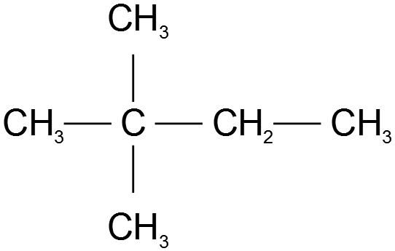

Description | Marks
correct structure | 1
Total | 1

(ii) hexane (1 mark)

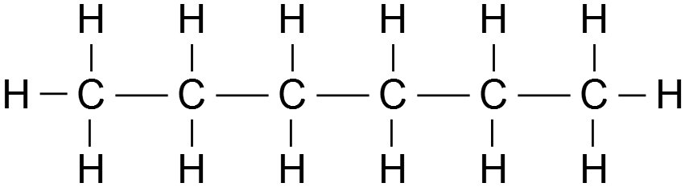

Description | Marks
correct structure | 1
Total | 1

(b) These compounds are both saturated, non-polar hydrocarbons but they are isomers of each other that have different structures. Discuss, with explanations, equations and diagrams as required how these similarities and differences affect the behaviour of the compounds. Include in your answer types of reactions, solubility in water and boiling points. (11 marks)
Description | Marks
types of reactions
both undergo substitution and combustion reactions | 1
equation for the combustion of C₆H₁₄ (same for both isomers) | 1
equation for a substitution reaction of 2,2-dimethylbutane | 1
equation for a substitution reaction of hexane | 1
solubility in water
both isomers insoluble in water (polar) as they are non-polar molecules | 1
can only form dispersion forces/solute-solvent IMF’s are weaker than those between water molecules | 1
boiling points
hexane will have a higher boiling point than 2,2-dimethylbutane | 1
due to greater dispersion forces, boiling overcomes the IMF | 1
show comparative surface area with labelled diagram | 1
structure of answer
comparing the two isomers (not just listing properties of each) | 1
explanation linked to given diagrams/equations where required | 1
Total | 11

Question 31 (22 marks)

A class of Year 11 students carried out a series of experiments to investigate the factors that affect the rate of a chemical reaction. The reaction used was sodium thiosulphate reacting with dilute hydrochloric acid. The reaction causes the solution to become a suspension with small particles of solid floating in the reaction mixture.

The molecular equation for this reaction is shown below.

Na₂S₂O₃(aq) + 2 HCℓ(aq) → 2 NaCℓ(aq) + H₂O(ℓ) + SO₂(g) + S(s)

(a) Rewrite this equation as an ionic equation. (2 marks)

S₂O₃^{2–}(aq) + 2 H⁺(aq) → H₂O(ℓ) + SO₂(g) + S(s)

Description | Marks
correct species | 1
balanced | 1
Total | 2

(b) State two characteristics of a solution that make it different to a suspension.
(2 marks)
Description | Marks
Any two from:  - a solution contains particles that are too small to be seen  - a solution is a homogeneous mixture  - a solution is clear  - a solution does not contain any (particles of) solid | 0-2
Total | 2

The rate of the reaction was monitored by using a light sensor as shown in the plan view below. As the suspension was formed, the solution became opaque and the light was blocked from reaching the sensor.
Detector
Light Source
Reacting chemicals in beaker
path of light

The timer was started when the chemicals were mixed and stopped when the sensor no longer detected light from the source.

(c) Name the product from the reaction that is preventing the light reach the detector. (1 mark)
Description | Marks
(solid) sulfur | 1
Total | 1
The results from the whole class are shown below

Trial | Volume of 0.10 mol L⁻¹ sodium thiosulfate  (mL) | Volume of 0.10 mol L⁻¹ HCℓ(aq)  (mL) | Volume of water  (mL) | Concentration of sodium thiosulphate in reaction  (mol L⁻¹) | Temperature of reaction  (°C) | Time taken  (s) | Rate of reaction (1/time)  (s⁻¹)
1 | 5.0 | 5.0 | 40.0 | 0.010 | 25 | 50 | 0.020
2 | 10.0 | 5.0 | 35.0 | 0.020 | 25 | 24 | 0.042
3 | 10.0 | 5.0 | 35.0 | 0.020 | 21 | 13 | 0.077
4 | 15.0 | 5.0 | 30.0 | 0.030 | 25 | 17 | 0.059
5 | 20.0 | 5.0 | 25.0 | 0.040 | 25 | 12 | 0.083
6 | 30.0 | 10.0 | 20.0 | 0.060 | 25 | 7 | 0.143
7 | 40.0 | 5.0 | 10.0 | 0.073 | 25 | 8 | 0.125
8 | 40.0 | 5.0 | 5.0 | 0.080 | 25 | 6 | 0.167
From these results your task is to identify the relationship between the concentration of the sodium thiosulphate and the rate of the reaction.

(d) (i) List all the numbers of the trials from the results above that are not valid for
this task and should not be used. (1 mark)

Description | Marks
Trials 3, 6 and 7 | 1
Total | 1

(ii) Explain the reasoning for your selection of each of the trials selected in your answer to (d) part (i). (4 marks)

Description | Marks
Trial 3 is at a different temperature | 1
temperature will affect the rate of the reaction | 1
Trial 6 has a different amount/concentration of the hydrochloric acid | 1
Trial 7 has a different total volume of solution | 1
Total | 4

(f) Plot the valid results from the results on the grid below. (5 marks)

Description | Marks
suitable scale on both axis | 1
suitable title on both axis | 1
correct units on both axis | 1
correct plotting of points | 1
Line of best fit | 1
Total | 5

(g) Describe, and, using the collision theory explain, the relationship between the concentration of the sodium thiosulphate and the rate of the reaction. (5 marks)

Description | Marks
As the concentration of the sodium thiosulphate increases the reaction rate increases | 1
proportionally | 1
rate of reaction is dependent on the number of successful collisions between reacting particles | 1
increasing the concentration of the reactants increases the total number of collisions | 1
therefore the number of successful collisions will increase | 1
Total | 5

(h) A version of this experiment can be carried out using the human eye to judge when to stop the stopwatch by looking through the reaction mixture and stopping the stopwatch when a cross on the opposite side of the mixture is obscured from view.

Will this method of measurement introduce systematic error, or random error to the experiment? Justify your answer. (2 marks)

Description | Marks
No mark for systematic or random, both marks for the justification
either:
random error because it will be difficult to accurately judge when the cross disappears | 1
and the person might stop the stopwatch before or after the ‘actual’ time | 1
or:
systematic error because it will be difficult to judge exactly when the cross disappears and there will always be a ‘lag time’ after the person has seen the cross disappear. | 1
this is systematic error as the recorded time wil always be longer than the ‘correct time’ | 1
Total | 2

